Lab Report

Team
Name/Mohamed Mostafa Sayed ID/22011170
Name/Ali El-Deen Maher ID/22010934

Project Overview
The objective of this project is to design and implement a scalable network for Company X, an autonomous system with branches in Cairo and Alexandria. The network connects three distinct buildings (Cairo B1, Cairo B2, and Alex B1) to ensure seamless data transfer and reachability between all departments.

Key Modifications
While the original design specified a Service Provider (SP) cloud, this implementation utilizes a Serial Interface connection between the Cairo Hub (Router R3) and the Alexandria Branch (Router R4) to simulate a dedicated point-to-point leased line.

Network Design & IP Addressing Scheme
The network uses a Fixed Length Subnet Masking (FLSM) strategy. Each department is allocated a /24 subnet, providing 256 addresses per network to simplify future expansion.

IP Assignment Table

Branch | Building | Department | Network Address | Subnet Mask | Gateway
Cairo | Building 1 | Sales (Sw1) | 20.1.1.0 | 255.255.255.0 | 20.1.1.1
Cairo | Building 1 | HR (Sw2) | 30.1.1.0 | 255.255.255.0 | 30.1.1.1
Cairo | Building 2 | IT (Sw3) | 40.1.1.0 | 255.255.255.0 | 40.1.1.1
Alex | Building 1 | Operation (Sw4) | 50.1.1.0 | 255.255.255.0 | 50.1.1.1

Infrastructure Links
  - R1 - R3 (Internal Cairo): 10.1.1.0/24
  - R2 - R3 (Internal Cairo): 60.1.1.4/2
  - R3 - R4 (Serial External): 70.1.1.0/24

Implementation Details

Routing Configuration
The network utilizes a hybrid routing approach to balance internal speed and external

scalability:
  - Internal Routing (EIGRP): - Configured between Routers R1, R2, and R3.
    - Protocol: EIGRP (Enhanced Interior Gateway Routing Protocol).
    - Purpose: To manage traffic between Cairo Building 1 (Sales/HR) and Cairo Building 2 (IT).

External Routing (BGP):
    - Configured between Router R3 (Cairo) and Router R4 (Alexandria).
    - Protocol: BGP (Border Gateway Protocol).
    - Autonomous Systems: Cairo (100) and Alexandria (200).
    - Connection Type: Serial Link.

Switching & PC Configuration
- Each department is assigned two Virtual PCs (VPCS) to verify connectivity.
- Switches are used on the access layer to provide local connectivity within departments.

Testing and Reachability
The implementation was verified using the GNS3 simulation platform. Success criteria were met through the following tests:
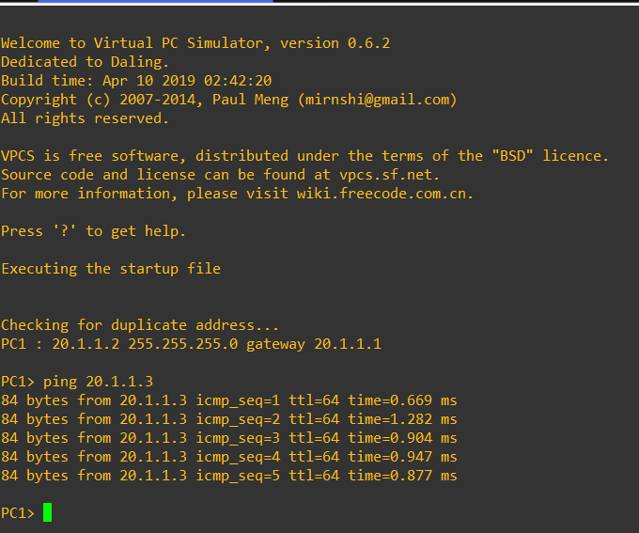
- Intra-Building Connectivity: Successful pings between PCs in Sales and HR (via R1).

- Inter-Building Connectivity: Successful pings between Sales (B1) and IT (B2) via the EIGRP internal paths on R3.
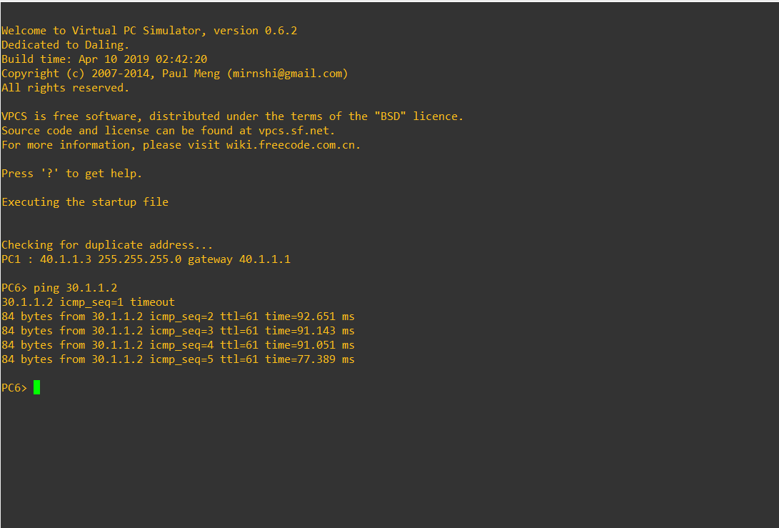

- Inter-Branch Connectivity: Verified reachability between Cairo Sales and Alexandria Operation through the BGP peering established over the Serial link.
